1. Turn right onto Rt.16 as you exit the main gate. After driving past AEON, move onto the GREEN colored lane.

2. Drive up the ramp onto **HONCHO-YAMANAKA** Road. Keep left at the 1st Y-split following the signs for **YOKOHAMA-YOKOSUKA** **(Yoko-Yoko)** Toll Road.

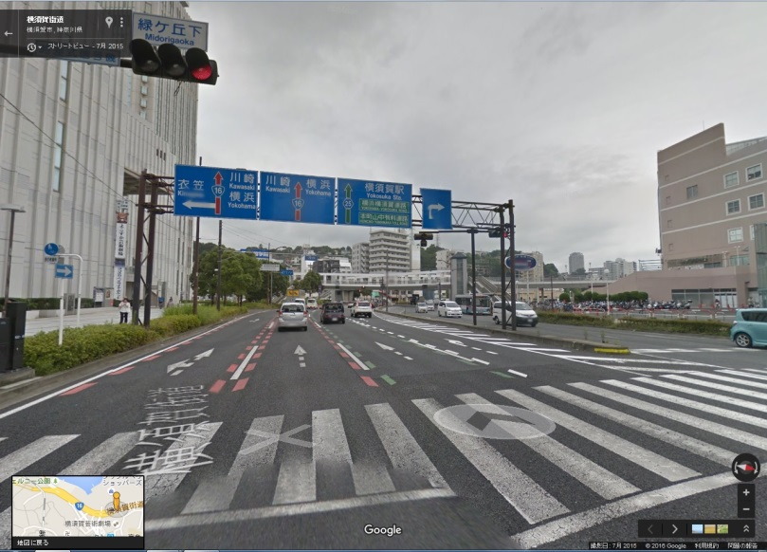 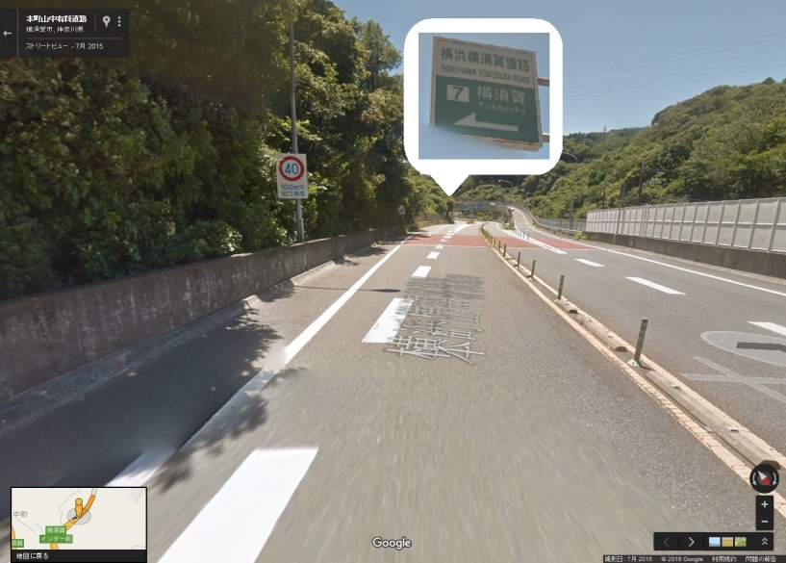

**COASKAA**

4.Continue straight on Yoko-Yoko Rd, heading toward HACHIOJI(**19km).** Pay 620yen at the Kariba toll gate.

3. Take a ticket at the next toll gate, keep right at the 2nd Y-split following the signs for **YOKOHAMA.**

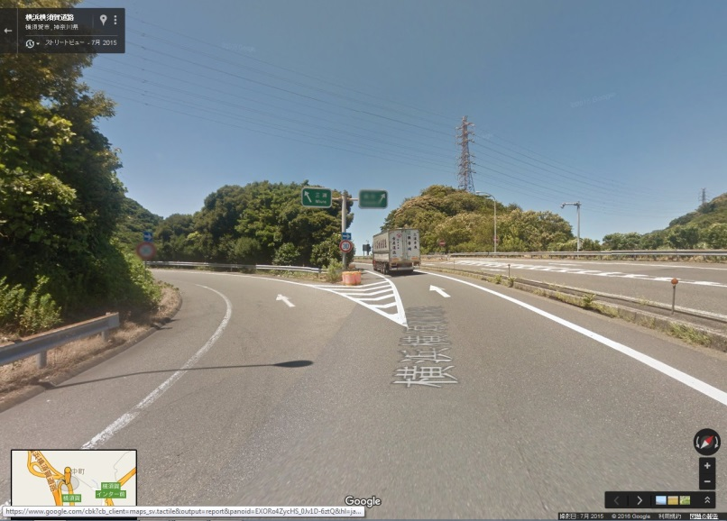 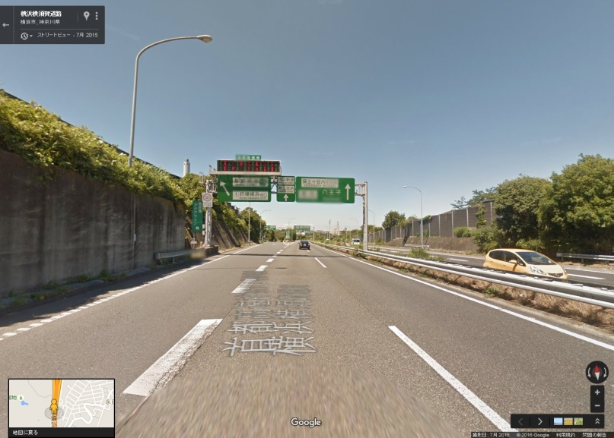

**八王子**

**HACHIOUJI**

**保土ヶ谷バイパス**

**HODOGAYA BY-PASS**

**横浜**

**YOKOHAMA**

6. Move into the leftmost lane. Keep left lane at 3rd Y-split and follow the signs for **SHIMOKAWAI/SEYA.**

5. After the toll gate, continue straight on **HODOGAYA BY-PASS** for about **9km.**

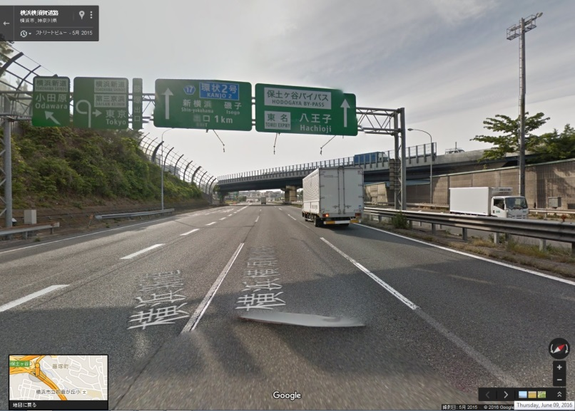 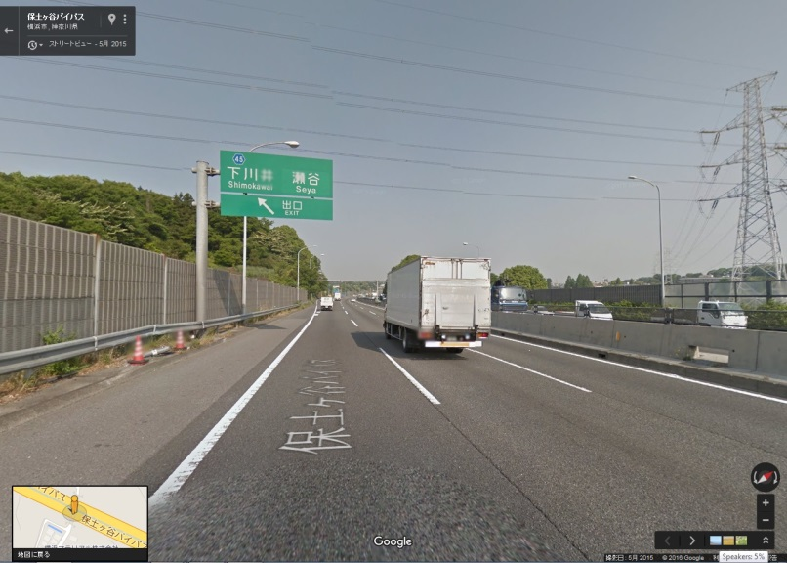

**下川井　　　　　瀬谷**

**SHIMOKAWAI　　SEYA**

7. Turn RIGHT onto Rt.45, then keep straight on Rt.45 for about **5.5km**.

8. Keep straight merging onto Rt.140.

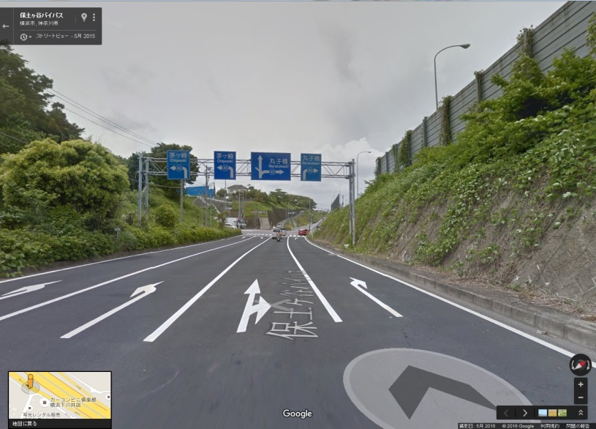 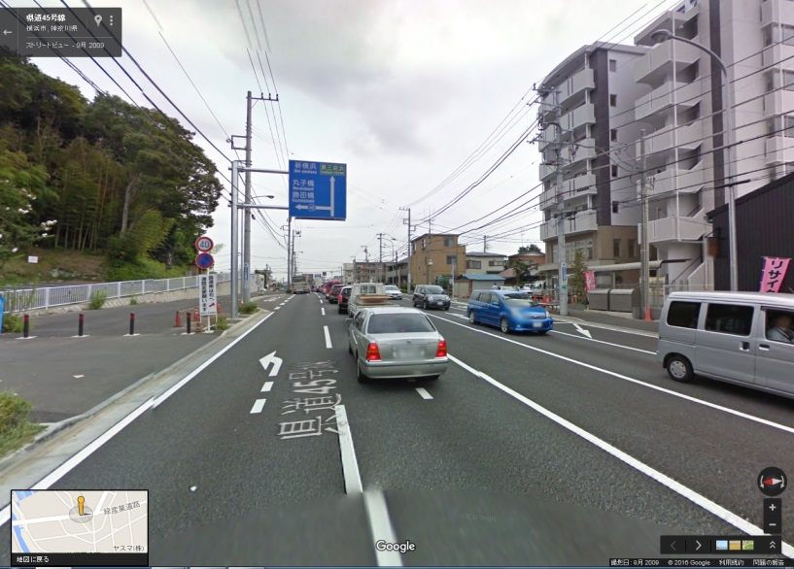

9. About 550m ahead after driving past PANASONIC factory on your left,

Turn left at **DEZAKIBASHI** traffic signal.

10. Turn left at the **first** corner shown in the picture below.

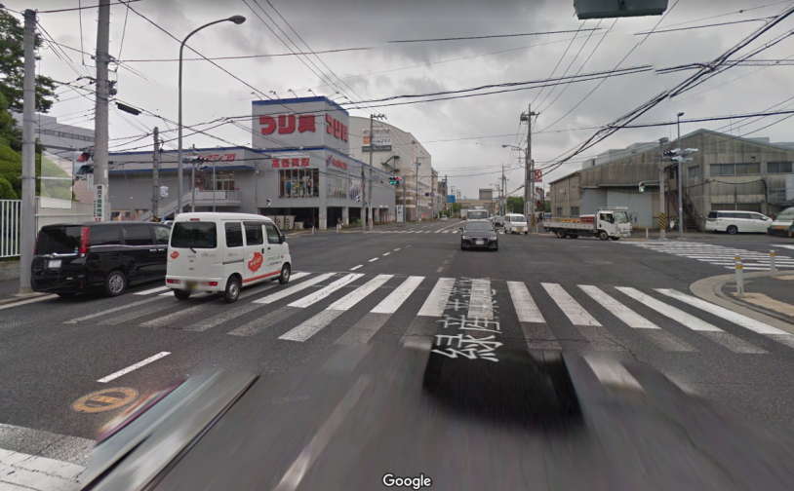 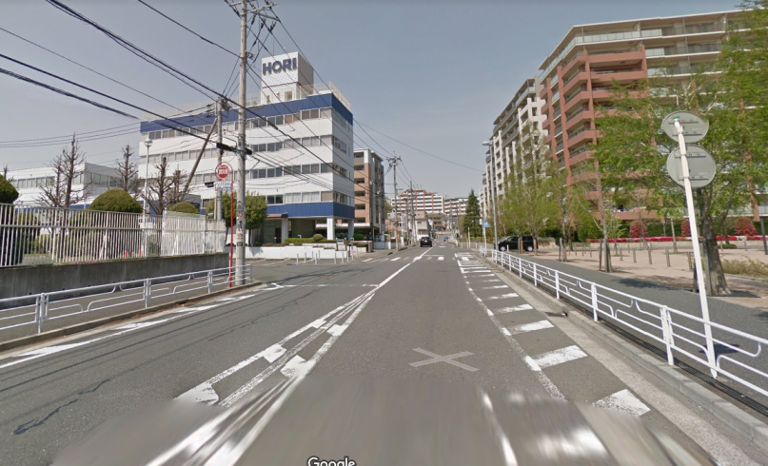

11. About 250m ahead, Mini Car LTO New office will be seen on your left.

**MINI CAR LTO**　　　　　　　　　 **(KEIJIDOUSHAKENSAKYOUKAI KANAGAWAJIMUSHO 軽自動車検査協会神奈川事務所)**

Address: 770-1 Saedo-cho, Tsuzuki-ku, Yokohama 　　　Phone #: 050-3816-3118

**HOUR OF OPERATION** MON – FRI 08:45 – 11:45 13:00 – 15:30 CLOSED: SAT, SUN, and JAPANESE HOLIDAY

